- Executive Summary
This project analyzes BlinkIT’s grocery dataset to understand sales patterns, item characteristics, and outlet behaviors. Using over 8500 entries, we explored how product types, outlet attributes, and visibility influence sales and customer ratings. Key insights can help improve inventory decisions, outlet planning, and marketing strategies.
- Introduction
Blinkit is a fast-moving grocery delivery platform. The project aims to extract actionable insights from historical sales and product data to:
- Identify factors impacting sales
- Assess outlet performance
- Explore customer preferences via rating and visibility

- Methodology

- Tools Used: Excel
- Data Source: Provided Excel file with 8,523 rows and 12 features
- Steps:
Data Cleaning:
After importing to the power BI, I transformed to the power query editor. As the dataset I taken was almost clean and I have done few steps as follows
- Standardized inconsistent entries (e.g., LF to Low Fat and reg to Regular)
- Business objectives
- Identify top performing product categories.
- Analyze outlet-based sales performance.
- Understand the impact of item and outlet attributes on sales.
- Offer actionable recommendations for inventory and outlet optimization.
- Insights Extracted

- Item Type Analysis
- Top 3 Categories: Fruits & Vegetables, Snacks, Household
- Least Stocked: Seafood, Breakfast, Starchy Foods
- Fat Content Distribution
- Regular Fat Items dominate inventory
- Tier 3 outlets sell more regular fat items
- Low-fat items are more popular in Tier 1 regions
- Sales Trend (by Year)
- Sales peaked in 2018 with $205k
- Decline post-2019 followed by slight recovery in 2022
- Outlet Insights
- Highest Sales: Tier 3 outlets
- Most Effective Size: Medium outlets
- Top Performing Type: Supermarket Type 1 (highest visibility)
- Visual Dashboards Used

- Metrics Cards: Total Sales, Ratings, Items, Average Sales
- Bar & Donut Charts: Item Types, Outlet Sizes, Fat Distribution
- Line Chart: Sales trend over years
- Matrix: Outlet-wise breakdowns (Sales, Visibility, Ratings, Items)
7. Creating Dashboard:
- After the data summarizing a dashboard created by using power BI
- Using KPI’s, bar & donut charts, line chart, matrix, slicers for outlet size, outlet location, item type.
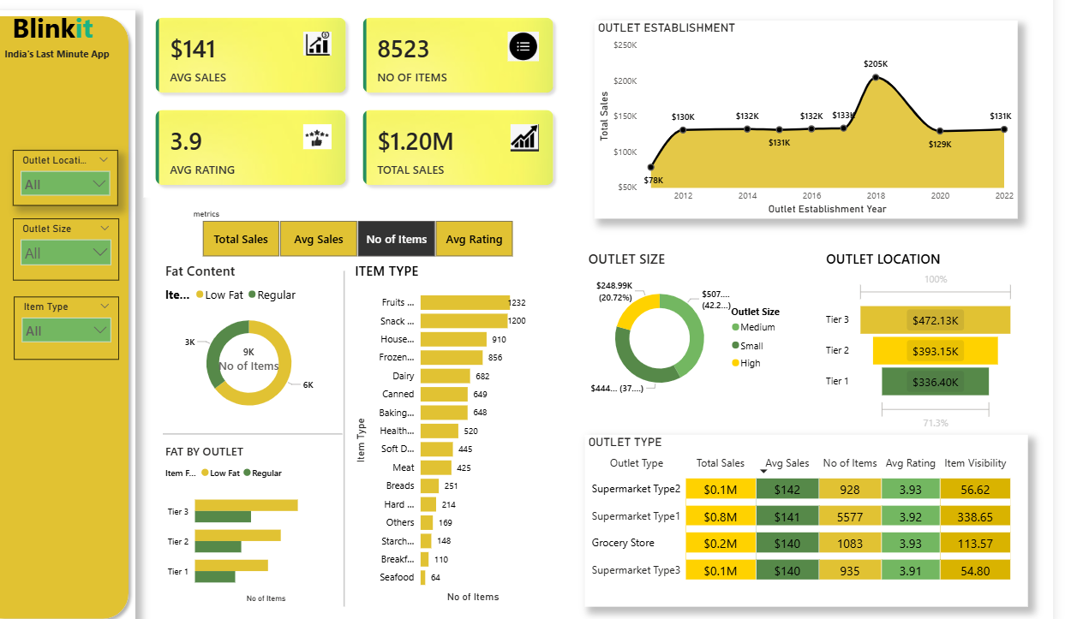

8. Insights & Recommendations
- Invest in Tier 3 Markets: Highest revenue contributors, indicating strong demand.
- Expand Medium Outlets: Best performing size category in terms of sales.
- Promote High-visibility Items: Supermarket type 1’s success links to highest item visibility.
- Enhance Low Fat Offerings in Tier 3: These outlets have more regular fat items; balancing can improve health-conscious customer engagement.
- Diversity Item Types: Focus on underrepresented categories like seafood and breakfast to capture niche demand.

9. Conclusion
This dashboard provides a strategic overview of Blinkit’s retail and operational metrics. It is a valuable tool for understanding sales performance, inventory strengths, and consumer behavior trends across various outlet types and locations.

Prepared by:
Shainaz begum

